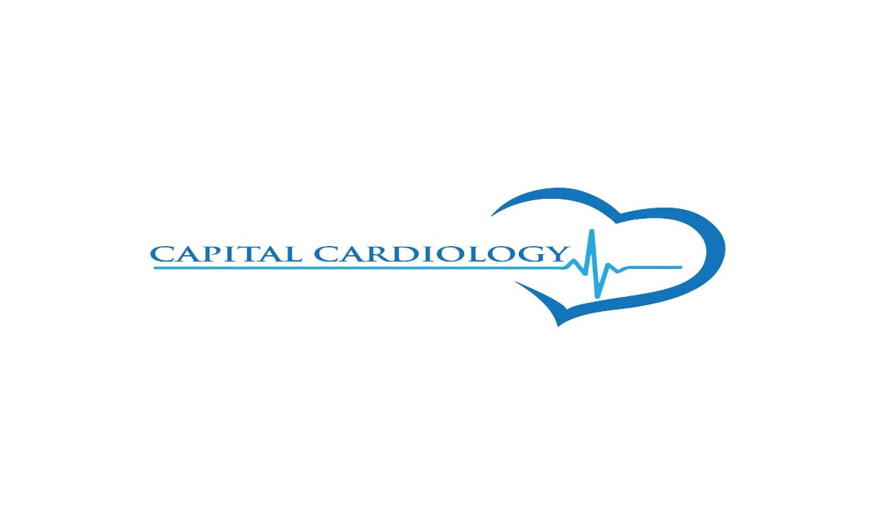

2 Gurdwara Rd. Suite #602

Ottawa, Ontario

K2E 1A2

Cardiovascular Technician (CVT)

Job details
Salary
$32–$37 an hour
Job type
Full-time
Part-time
Permanent

Benefits

Pulled from the full job description
Dental care
Extended health care
Life insurance
On-site parking

Full Job Description
Capital Cardiology is a state-of-the-art multi-modality cardiovascular centre in Ottawa. Our team of cardiologists, and allied health care professionals are dedicated to providing excellent diagnostic and consultation services to patients referred to us from the entire Ottawa Carleton Valley region. In addition to Cardiology Consultation, we offer Echocardiogram, Stress Echocardiogram, Holter Monitoring, ECG, Ambulatory Blood Pressure Monitoring, Persantine SPECT and Exercise SPECT.
Job Duties (Experience in performing high quality testing that includes):
- Stress Testing
- Stress Echo (Treadmill)
- Nuclear Lab (Exercise Stress and Persantine)
- Holter and ABPM hookups
- Holter scanning with arrhythmia recognition skills
- ECG
*Requirement:
- Cardiovascular Technician diploma.
- Active registration and membership in good standing with the Canadian Society of Cardiology Technologists (CSCT).
- Experience in obtaining IV is a must.
- Minimum 1 year experience as a CVT.
- Previous experience in Nuclear Medicine Stress Testing is highly preferred.
- Canadian citizen or permanent resident of Canada.
Work Hours:
Full time Or Part time position
Monday-Friday day shifts and some Saturdays.
Over-time is available but not compulsory.
How to Apply: Please apply through the Indeed web portal. Only those candidates under consideration will be contacted.
Additional pay:
- Overtime pay when applicable.
- Vacation pay: 4% in lieu of vacation.
Benefits:
- Dental care.
- Extended health care.
- Life Insurance.
- Free On-site parking.
- Competitive wages (wage will be based on qualifications and experience).
Job Types: Full-time, Part-time, Permanent
Salary: $32.00-$37.00 per hour
Additional pay:
- Overtime pay
Benefits:
- Dental care
- Extended health care
- Life insurance
- On-site parking
Flexible language requirement:
- French not required
Schedule:
- 8 hour shift
- Monday to Friday
- Weekend availability

Experience:
- Cardiovascular Technologist: 1 year (preferred)
- Obtaining IV: 1 year (preferred)

Hiring Insights
Hiring 1 candidate for this role
Urgently hiring

For further information, please contact melanie@capitalcardiology.ca

